5/14/2019

Waste Awareness

SITUATIONAL ANALYSIS

Riley Park South Cambie Community Vision Group

Nishtha chawla, dheeraj kaushik, diego NUNEZ, cristian BRAZALES, felipe

1. **BACKGROUND**

Riley Park–South Cambie Community Visionsis a Vancouver City Council mandated citizens’ advisory group that serves as a public “watchdog” for community planning in the area between 16th and 41st. and Oak and Fraser Streets. The RPSC’s goal is to maintain and strengthen the community’s identity in the face of considerable change [1]. RPSC has four sub committees Traffic, Arts & Culture, Gardening and Housing. **RPSC Meetings are generally held on the 3rd Wednesday of each month and the m**eetings are open to all.

Riley Park South Cambie neighbourhood is the home of tourist mecca-Queen Elizabeth Park. The area’s two community centres and neighbourhood house are heavily used. Shopping areas on Main and Fraser streets are bustling centers of the city thus bringing a lot of daily footfall to this community. Riley Park is also home to Mountain View Cemetery, the city's only burial ground. It takes up more than 42 hectares of space west of Fraser Street, between 31st and 43rd avenues [2]. Residents have good connections between Canada Line and important neighbourhood destinations (e.g. Queen Elizabeth Park, Riley Park Community Center), but biggest concerns are the impacts of these stations on crime, vandalism, and litter. Apart from residents, the community handles a lot of visitors and tourists daily thus making waste management a challenging task.

The vision and mission statements of RPSC are listed below:

* Create Neighbourhood Centres and Enhance Important Shopping Areas
* Make Streets Safer and More Attractive
* Enhanced Community Services
* Build a Safer Community
* Improve Parks, Streets, Lanes, and Public Places
* Protect and Enhance the Environment
* Improve Community Involvement in Decision making

Keeping in line with the vision statement, the RPSC maintains sidewalks, gutters, lanes, parking lots, storefronts, garbage areas, and loading bays by keeping it cleaner and maintaining it better with help from private businesses and the City of Vancouver.

1. **ISSUE STATUS**

**Category 1: Income & Poverty**

The median total family income in the community is a little above the median total income of Vancouver which implies it is one of the better neighbourhoods of the city. However, the rents in this part of the city are high where average monthly cost of renting and owning is higher than the rest of Vancouver which means many families must have big mortgages or struggling to pay rent [3]. Not only this, 10% of the people in the community fall under the Low-Income bracket. Hence, it seems like a challenge to motivate people to allocate resources for waste management when the housing seems unaffordable which has a higher priority.

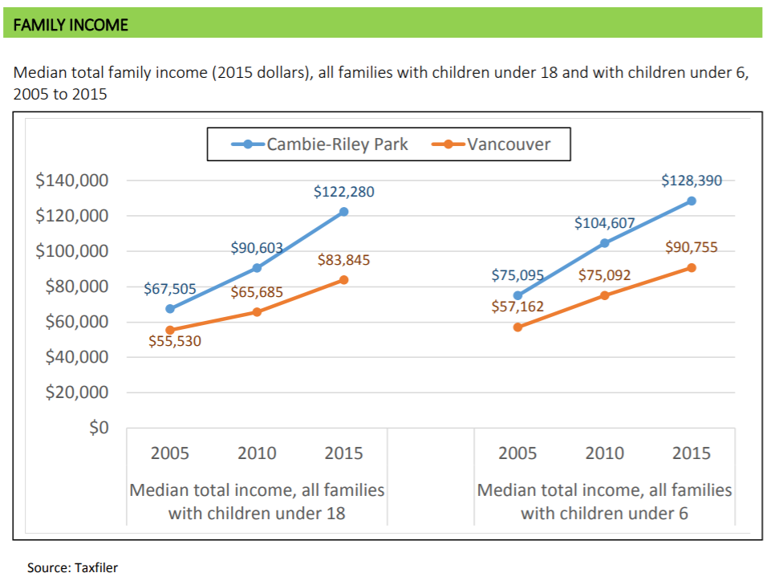

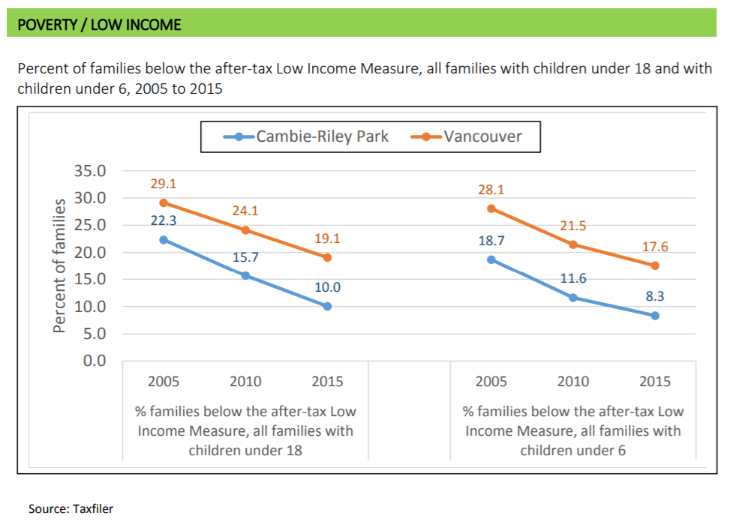 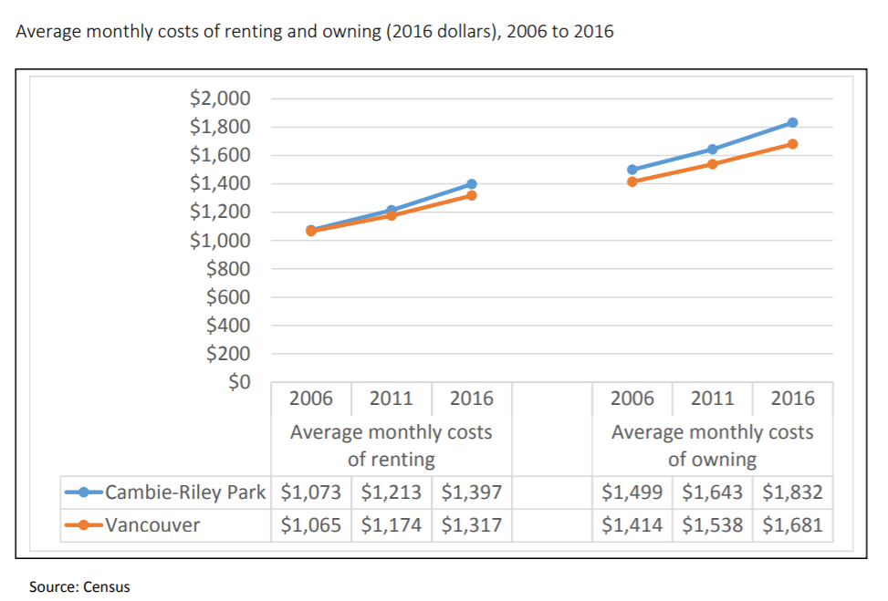

**Category 2: Population**

The % of children in RPSC community is more than the rest of the city. The households with children tend to generate more waste and have less time on their hands to manage the waste effectively. Hence this poses another challenge for the “Waste Awareness and Action To Reduce Household Waste” program.

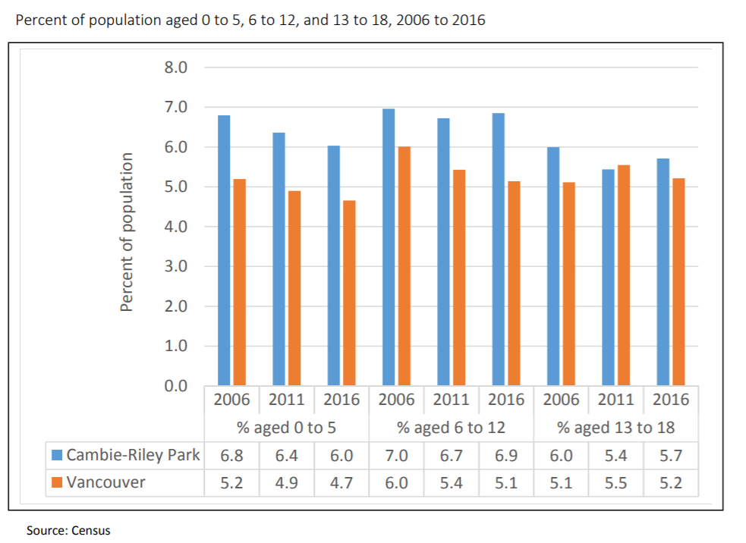

**Category 3: Language**

While English speakers are the majority, Cantonese, Mandarin and Tagalog are spoken by many residents. Language Barrier is one of the major issues in getting the message across as people who do not have English as a first language might not understand the goal and meaning of waste awareness programs.

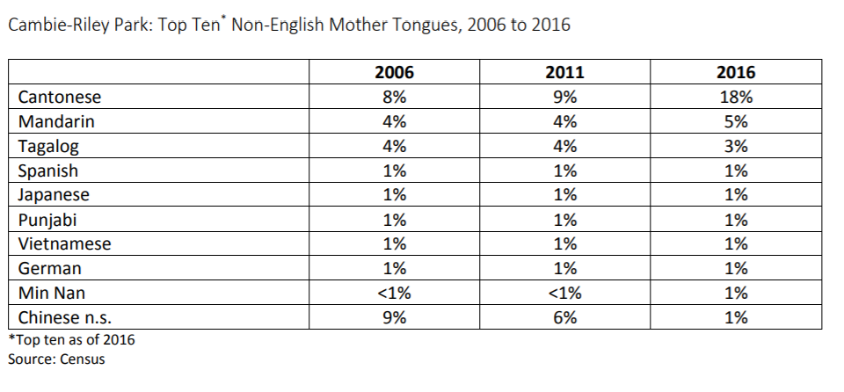

**Category 4: Immigrants & Indigenous Population**

More than a quarter of the community population is of immigrants where the households lay a higher priority in finding housing and employment in comparison to building a sustainable community. Convincing people to go the extra mile in a foreign land to meet the program goals might be another daunting task.

1. **CAUSES OF ISSUES**
2. The majority of the residences are single detached houses or duplex and apartments which are fairly small in size. People have small spaces and big families to raise which makes it difficult to have separate bins and bags for each type of waste. (Average household size as per 2016 census is 2.2 in RPSC area)
3. There is no family resource program in RPSC which is a not-for-profit organization that supports the development of diverse healthy families with children prenatal to six years old using a family-centred practice.  [4]. This means the community people need to travel to other places for their needs or the burden comes on their shoulders thus making their commitment to the environment more difficult.
4. There is only one neighbourhood house and no Strong Start center in RPSC [5]. StrongStart Centres are for preschool aged children where a quality early learning experience is offered to parents and caregivers with children ages zero – fi­ve years. There is no cost to families, but the parent/caregiver is required to remain with their child and participate in the program. This again implies the community has lesser resources to aid the families with children under the age of six years which is an indirect cause of less community participation from such families.
5. The trends in Issue Status shows that on an average 5% of the population in the community comprises of young children and teenagers. Nothing is being done in the community currently to educate the kids for a better and sustainable environment. Weekend programs can be arranged in parks or schools to increase waste awareness.
6. **KEY INTERVENTION STRATEGIES**

Major intervention strategy is by avoidance of waste through an aggressive waste reduction campaign and through the recovery of materials and energy from the waste that remains in the sites.

First strategy is to minimize waste generation by transferring waste management responsibilities to producers and consumers. This can be done by reducing or eliminating materials from entering the solid waste system which restrict the opportunity to attain reuse or recycling. This can also be achieved by providing information and education on options to reduce waste.

Another strategy is to maximize reuse, recycling and material recovery which can be increased by improving the opportunity for reuse and by increasing effectiveness of existing recycling programs. Private sector recycling is also an option to achieve this goal. Third major strategy is to recover energy from the waste stream after material recycling and using this energy generated from waste to be used for electricity or heating purposes. Non-recyclable material can be used as fuel. Fourth strategy is to dispose of all remaining waste in landfill, after material recycling and energy recovery by using the available landfill sites and also developing contingency landfill sites.

Strategies that are currently underway to deal with the issue [7]:

* Greenest city action plan by City of Vancouver
* Zero waste 2040 – a long term strategic vision for Vancouver
* Waste wizard tool
* Van Sort – a waste sorting game to increase waste awareness
* Notifications for Collection Schedule
* Interactive videos to increase waste awareness
* Providing bins, boxes and bags to community

Challenges associated with strategies include:

* Motivation of the community
* Supplies such as bins, bags and baskets
* Shortage of Landfill sites and recycling plants
* Ensuring public safety while handling waste such as glass craps
* Strict imposition of fines for not following waste sorting guidelines

1. **CONSULTATION CONSIDERATIONS**

Potential stakeholder for this project includes the following:

* The Little Mountain Neighbourhood House is one of the largest community groups in this area. As a newcomer settlement service, its members include large numbers of recent arrivals to Canada. [8]
* The Seed to Sky Garden group is one of the largest community-based garden groups in the city with some eighty families represented.
* The RPSC membership is more representative of the general population of the area representing a wide demographic many of whom are long-term residents of Vancouver and the area.

Interaction with community and stakeholders can be done at below possible locations:

* Community partners such as the libraries
* Local shops and Parks
* Community center
* Neighbourhood houses

Stakeholders and community members can be engaged and educated by using props as examples to educate people about waste sorting and management. Informative charts can be employed to increase awareness about different varieties of waste.

Outreaching the communities through different information sessions and presentations can be another way in which the waste management program can be introduced to the communities. Feedbacks can be collected from the communities through these kinds of activities and gatherings so that future improvements can also be suggested. These seminars and the workshops can be held in the community parks where the community people gather for other programs and a broader range of the people can be covered through these presentations. The stakeholders will be consulted for different kind of research questions so that the proper needs of the community can be taken into consideration.

Further the community can be encouraged to share their own experiences which can set an example for the others to choose the same strategy. The expansion of these kind of events further to the street festivals can bring even more knowledge among the community people about waste management.

1. **REFERENCES**

[1] RPSC Visions Group. (2019). Retrieved from <https://rpscvisions.ca/>

[2] Howell, M. (2019). Riley Park: The neighbourhood at a glance. Retrieved from <https://www.vancourier.com/community/vancouver-special/riley-park/riley-park-the-neighbourhood-at-a-glance-1.388590>

[3] (2019). Retrieved from http://earlylearning.ubc.ca/media/yvr_demographic_profils/cambie-riley_park_demographic_report_final_07jan2019.pdf

[4] About Us. (2019). Retrieved from <http://www.frpbc.ca/about_us/>

[5] (2019). Retrieved from <https://www.vsb.bc.ca/Student_Learning/Early-Learners/StrongStart/Documents/sbfile/180913/StrongStart-brochure-2018-sep.pdf>

[6] (2019). Retrieved from <http://www.metrovancouver.org/services/solid-waste/SolidWastePublications/ISWRMP.pdf>

[7] Vancouver, C. (2019). Toward zero waste. Retrieved from <https://vancouver.ca/home-property-development/waste-disposal-and-recycling.aspx>

[8] About Us - Little Mountain Neighbourhood House. (2019). Retrieved from <https://web2.lmnhs.bc.ca/about/>

Proposal Introduction

1. INTRODUCTION

Recycling is one of the best ways to have a positive impact on the world in which we live. Recycling is important to both the natural environment and us. Disposed waste contributes to environmental problems including habitat destruction, surface and groundwater pollution, and other forms of air, soil, and water contamination. Incineration creates toxic substances, while landfills emit methane (which contributes to global warming) and other gases. On average, Canada generates 720 kg of waste per capita and the province of B.C generates 573 kilograms waste per capita, ranking second to Nova Scotia in generating lowest amount of waste per capita. [1] British Columbia has set provincial waste disposal targets with a long-term goal of lowering the municipal solid waste disposal rate to 350 kg per person by 2020/21. [2]. In 2017, the waste disposal rate for Metro Vancouver region was 477 kg/person. The City of Vancouver has a Greenest City Action Plan with a vision for Zero Carbon and Zero Waste city.

The Riley Park South Cambie, an official Vancouver Community Vision group, represents one of 16 city areas. RPSC has worked with the City Planning Department to provide input into planning and development initiatives in this area. Increasing the amount of household waste that is recycled has become a major goal for the City of Vancouver during the last two decades (3). However, the amount of overall waste has not significantly declined. The vision of RPSC is to enlighten and empower its community members to generate less waste to make a meaningful difference. This project on waste awareness and action to reduce household waste is based on the idea of a Grade 5 Science Fair Award Winner who conducted this survey in 2017-18 in Trail, BC.

The major intervention strategy is by avoidance of waste through an aggressive waste reduction campaign and through the recovery of materials and energy from the waste that remains in the sites. First strategy is to minimize waste generation by transferring waste management responsibilities to producers and consumers. This can be done by reducing or eliminating materials from entering the solid waste system which restrict the opportunity to attain reuse or recycling. This can also be achieved by providing information and education on options to reduce waste. [4]

Another strategy is to maximize reuse, recycling and material recovery which can be increased by improving the opportunity for reuse and by increasing effectiveness of existing recycling programs. Private sector recycling is also an option to achieve this goal. Third major strategy is to recover energy from the waste stream after material recycling and using this energy generated from waste to be used for electricity or heating purposes.[4] Non-recyclable material can be used as fuel. Fourth strategy is to dispose of all remaining waste in landfill, after material recycling and energy recovery by using the available landfill sites and also developing contingency landfill sites.

Strategies [5] that are currently underway to deal with the issue:

* Greenest city action plan by City of Vancouver
* Zero waste 2040 – a long term strategic vision for Vancouver
* Waste wizard tool
* Van Sort – a waste sorting online game to increase waste awareness
* Notification reminders for Collection Schedule
* Interactive videos to increase waste awareness
* Providing bins, boxes and bags to community free of cost
* Strict imposition of fines for not following waste sorting guidelines
* Annual rates billed for garbage collection based on size of bin registered

Challenges associated with strategies include:

* Motivation of the community
* Supplies such as bins, bags and baskets
* Shortage of Landfill sites and recycling plants
* Ensuring public safety while handling waste such as glass craps
* Increasing cost of collecting recyclables due to ban on scrap plastic import by countries such as China

Waste causes pollution which contributes to climate change and squanders more money, energy and natural resources than most of us realize. Increasing amount of wastes is wreaking havoc on our marine life and decreasing the quality of life for humans. Recycling not only helps in conserving our natural resources but also reduces the cost of production of many products. Making small changes in our everyday lives can make a powerful difference to the health of all living things and the province and planet we call home. Thus, bringing awareness to community about waste reduction is of utmost importance to achieve sustainability goals.

2.0 PURPOSE OF THE PROJECT

[This section highlights why this project is important and what challenge(s) you are seeking to overcome.

Your purpose for instance, might be to promote greater gender equity in a particular community. This section is generally short.]

This proposed project will engage the community to consider the amount and type of waste that it produces each week and consider steps that a family can realistically take to reduce the amount of material that it sends to the landfill.

-The city is doing this and that. Define the challenge (eg. families use single-use packages), educate the community. The broad purpose is the reduce waste

-Challenges: waste reduction; people buy a lot of single-use plastics; put more pressure on manufacturers. Motivate people to reduce waste: motivate people to do the sorting but most importantly motivate people to reduce waste (consume less)

-Raise awareness but also give people recommendations about how to reduce waste (give them an action plan with realistic steps)

-Include the goals written in the project description. Rephrase the purpose from Norm’s lists

-Keep it short (1 or 2 paragraphs). Half a page

[1] <https://www.conferenceboard.ca/hcp/provincial/environment/waste.aspx?AspxAutoDetectCookieSupport=1>

[2] <http://www.env.gov.bc.ca/soe/indicators/sustainability/municipal-solid-waste.html>

[3] APSC 461 Proj description

[4] <http://www.metrovancouver.org/services/solid-waste/SolidWastePublications/ISWRMP.pdf>

[5] <https://vancouver.ca/home-property-development/waste-disposal-and-recycling.aspx>